Estimation of post mortem interval by rearing Chrysomya rufifacies (Macquart, 1842) ( Diptera: Calliphoridae) : A case study from central India

B.Suri Babu ª, Himanshu Sharma^{a,*} , Meenakshi Bharti^{b}

ªRegional Forensic Science Laboratory Building, Bodhghat Colony, Jagdalpur-494001, District-Bastar, Chhattisgarh, India.
E-mail address: drsuribabu@gmail.com (B. Suri Babu), himanshusharma0912@gmail.com ( Himanshu Sharma)

^{b}Department of Zoology and Environmental Science, Punjabi University, Patiala-147002, Punjab, India.
E-mail address: adubharti@yahoo.co.in (Meenakshi Bharti)

* Corresponding author. Regional Forensic Science Laboratory Building, Bodhghat Colony, Jagdalpur-494001, District-Bastar, Chhattisgarh, India.
Tel.: +91 7587265259.
E-mail addresses: himanshusharma0912@gmail.com (Himanshu Sharma)

ABSTRACT: The estimation of Post Mortem Interval(PMI) of a headless corpse of a (male) foetus of 9 months found in the Forest nursery at Jagdalpur, District Bastar, State Chhattisgarh, India was determined on the basis of developmental period of 2nd instar larvae of blowfly Chrysomya rufifacies (Macquart).

Keywords: Blow flies, Chrysomya rufifacies, forensic entomology, maggots, Post Mortem Interval (PMI),India.

1. Introduction:

The presence of some species of insects, including their immature stages can provide information about the location, time and condition of cadavers and hence forensic entomologists make use of the same in crime investigations like [1,2,3,4,5] had reported that insect evidence has been helpful in determining post mortem interval, drug verification, determination of ante mortem trauma and verification of relocation of corpses.

Erzinclioglu [6] had found in his study that various conventional methods are used for the estimation of the exact time since death or post-mortem interval, but the methods cannot provide an accurate estimate of PMI not more than two days after death and thus an entomological investigation is a must in such cases. Moreover the insect evidence can supplement the finds from other techniques in cases where the cadaver is found infested with fly [7].

Greenberg [3] reported that the blow flies are the most important forensic indicators because they are usually the first to colonize carcass, often within minutes or even seconds of exposure. Fuller [8] reported that the first instar larvae of hairy maggot blowfly, Chrysomya rufifacies feed on decaying tissue, where as the second and third instar larvae can also exist also as facultative predators of other necrophilous fly larvae. Hall and Haskell [9] found that forensically important Ch. rufifacies has been used in number of cases is used to gage post mortem interval or situs of death. But in India the situation is quiet grim as only handful of case reports has been published where entomological data is used to determine post mortem interval(PMI) like [10,11,12].

The present study is the first case report from India where PMI of a carcass was determined by rearing second instar maggots of Ch. rufifacies up to adults with the help of Accumulated Degree Hour’s (ADH) calculation method.

2. Material and methods:

On 7th July,2012 a body of a male foetus of 9 months was found in the Nursery of State Forest Department, Jagdalpur, Chhattisgarh State, India. The body was in advance stage of decomposition. The chest and belly region were found infested with maggots mass, No adult flies were observed on and around the body.

The putrefied mass of male foetus along with second instar [ Fig. 1.] were transferred to a 500ml plastic container in which mixture of saw dust with soil of scene of occurrence was placed at the bottom. The mouth of the container was closed with a perforated lid to facilitate air circulation and to prevent newly emerged flies from escaping the container. The maggots were observed daily and different immature stages and adults were collected and identified with the help of taxonomic keys by Smith[13],R. Senior-White[14]. The identification was further confirmed by Dr. Pankaj Kulshrestha, Senior Forensic Entomologist, Medico-Legal Institute, Bhopal (M.P), India.

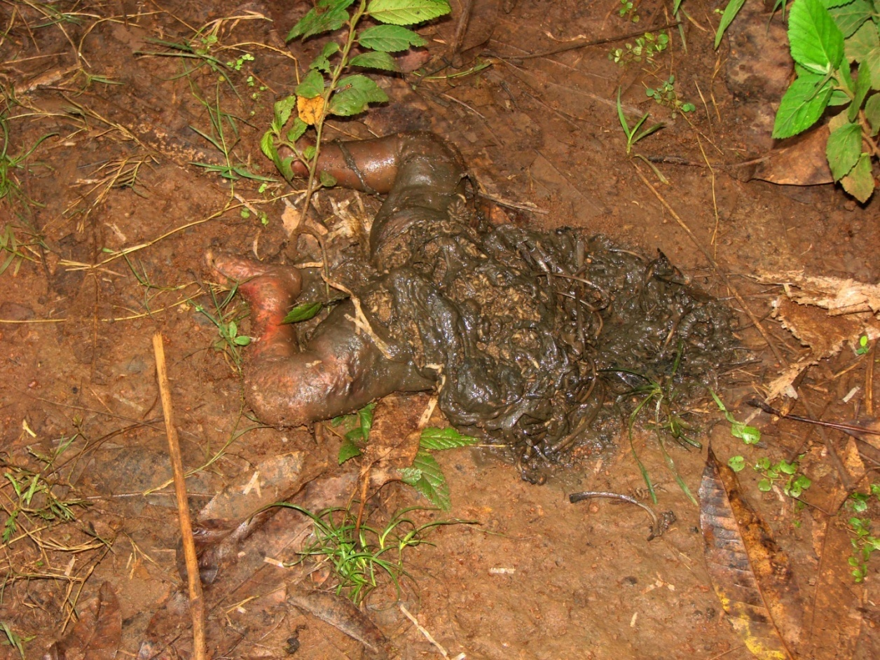

Fig. 1. Headless corpse of male child found in forest nursery, Jagdalpur.

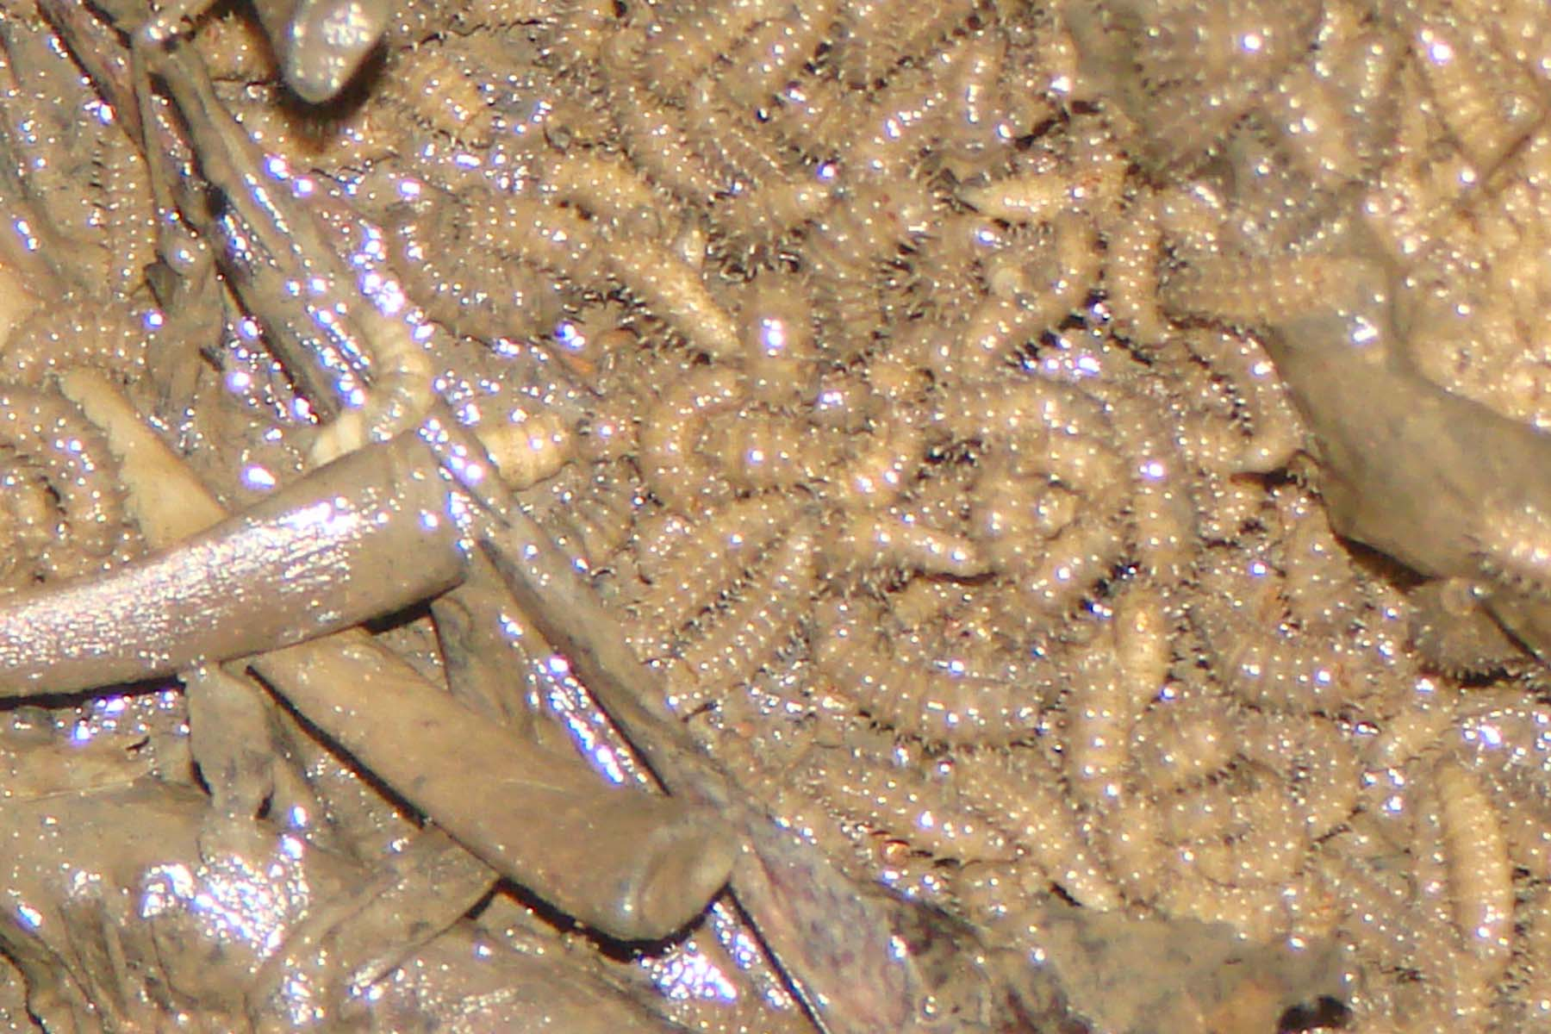

Fig. 2.Mass of maggots of 2nd instar Chrysomya rufifacies in the belly region of corpse.

The photographs from the scene of crime [Fig. 2.], and surround vegetation and the corpse were taken. Data of maximum and minimum temperature, rainfall and relative humidity was procured from The Government Agromet Observatory, Shaheed Gundadhoor College of Agriculture and Research Station, Jagdalpur(C.G) located a short distance from the scene of crime.

3. Results:

The rearing has been carried out in the natural weather conditions in par with the actual scene of occurrence scene. The maximum temperature was recorded to be 32 and minimum temperature: 21; Humidity: maximum 96% and minimum 50%; Rainfall: maximum 76.2 mms and minimum 0.00 mms as shown in Table 2

As per FSE13 Crime Dossier; Forensic Entomology, Centre of Learning Technology, The University of Western Australia, Perth, Australia [15]; The time of development from egg hatch to adult emergence of Ch. rufifacies at constant temperature of 24 was adopted for use in the Accumulated Degree Hours method for determining the PMI laid out in Table 3.

The accumulated degree hours were calculated with help of threshold temperature for Ch. rufifacies considered as 10 as per source FSE07 Use of insects to help solve crime; Forensic Entomology, Centre of Learning Technology, The University of Western Australia, Perth, Australia [15] presented in Table 4 and 5.

On the basis of the above data, the determination of PMI was calculated using the Accumulated Degree Hours method for determining the PMI as shown in Table 6.

The PMI of the male foetus was determined to be 3.5 days and his death may occured between 18:50 to 19:50 Hrs on 3rd July 12. The autopsy surgeon gave a PMI of 3 to 5 days without definite cause of death,who performed autopsy on 8th July 12 at 10:30 Hrs.

4. Tables:

Table 1

Rearing of 2nd instar larvae to adult of Ch. rufifacies reared in the laboratory

Development Stage of  Ch. rufifacies | Length (mm) | Time Spent in Stage(Days)
Egg |  | -
1st Instar Larvae |  | -
2nd Instar Larvae | 11 to 12 | 1 (07/07/12)
3rd Instar Larvae | 13 to 15 | 2 (08/07/12-09/07/12)
PrePupae | 9 | 1 (10/07/12)
Pupae- Adult emergence | 10 | 4 (11/07/12-14/07/12)

Table 2
Meteorological data of 01/07/12-14/07/12 for Temperature maximum, minimum; Rainfall and Relative humidity.

Meteorological data of 01/07/12- 14/07/12
Date | Max. | Min. | Rainfall | Relative Humidity
 | Temp | Temp | mms | I | II
01/07/12 | 32.0 | 21.0 | 5.2 | 88 | 70
02/07/12 | 27.0 | 21.0 | 3.8 | 96 | 66
03/07/12 | 27.5 | 21.5 | 76.2 | 91 | 81
04/07/12 | 25.5 | 21.4 | 1.2 | 91 | 72
05/07/12 | 28.0 | 22.6 | 0.0 | 80 | 51
06/07/12 | 31 | 21.5 | 4.5 | 91 | 81
07/07/12 | 25.5 | 21.7 | 21 | 96 | 76
08/07/12 | 25.6 | 21.2 | 8.6 | 91 | 80
09/07/12 | 25.5 | 21.5 | 1.6 | 96 | 72
10/07/12 | 26.0 | 21.0 | 0.0 | 93 | 60
11/07/12 | 28.7 | 22.1 | 1.2 | 86 | 52
12/07/12 | 30.5 | 22.5 | 0.0 | 91 | 54
13/07/12 | 31.0 | 22.8 | 2.0 | 91 | 50
14/07/12 | 30.8 | 22.1 | 27.0 | 91 | 70

Table 3
Development Time (hrs) of Ch. rufifacies at constant temperature of 24 as par FSE13 Crime Dossier; Forensic Entomology, Centre of Learning Technology, The University of Western Australia, Perth, Australia [15].

Development Stage of  Ch. rufifacies | Development Time (hrs) of Ch. rufifacies (at 24)
Egg stage | 21
1st Instar larvae | 30
2nd Instar larvae | 24
3rd Instart larvae | 24
Pupation-adult emergence | 264

Table 4
Determination of Accumulated Degree Hours(ADH ) for Ch. rufifacies life cycle from 01/07/2012 – 14/07/2012.

Date | Temperature |  |  | Threshold Temp ( for Ch. rufifacies) | Growing Degree Day Value (DD)  (Avg. temp – Threshold Temp.) | Accumulated Degree Hours
 | Max | Min | Avg.* |  | Growing Degree Day Value (DD)  (Avg. temp – Threshold Temp.) | DD x 24 hours
01/07/12 | 32.0 | 21.0 | 26.5 | 10 | 16.5 | 396
02/07/12 | 27.0 | 21.0 | 24 | 10 | 14 | 336
03/07/12 | 27.5 | 21.5 | 24.5 | 10 | 14.5 | 348
04/07/12 | 25.5 | 21.4 | 23.45 | 10 | 13.45 | 322.8
05/07/12 | 28.0 | 22.6 | 25.3 | 10 | 15.3 | 367.2
06/07/12 | 31 | 21.5 | 26.25 | 10 | 16.25 | 390
07/07/12 | 25.5 | 21.7 | 23.6 | 10 | 13.6 | 326.4
08/07/12 | 25.6 | 21.2 | 23.4 | 10 | 13.4 | 321.6
09/07/12 | 25.5 | 21.5 | 23.5 | 10 | 13.5 | 324
10/07/12 | 26.0 | 21.0 | 23.5 | 10 | 13.5 | 324
11/07/12 | 28.7 | 22.1 | 25.4 | 10 | 15.4 | 369.6
12/07/12 | 30.5 | 22.5 | 26.5 | 10 | 16.5 | 396
13/07/12 | 31.0 | 22.8 | 26.9 | 10 | 16.9 | 405.6
14/07/12 | 30.8 | 22.1 | 26.45 | 10 | 16.45 | 394.8
Avg.* - Average temperature for the particular day.

Table 5
Accumulated Degree Hours (ADH) of different stages in life cycle of Ch. rufifacies during laboratory rearing.

Development Stage of Ch. rufifacies | Dates | Accumulated Degree Hours (ADH) in Development Stage of Ch. rufifacies
Egg | - | -
1st Instar Larvae | - | -
2nd Instar Larvae | 07/07/12 | 326.4
3rd Instar Larvae | 08/07/12-09/07/12 | 645.6
Pre-pupae | 10/07/12 | 324
Pupae- Adult emergence | 11/07/12-14/07/12 | 1566

Table 6

Accumulated Degree Hours method for determining the post mortem interval (PMI) of the male foetus .

Accumulated Degree Hours method
Collection of maggots: | 2nd instar larvae from male foetus of 9 months at 16:00 on 7th July 12.
Accumulated Degree Hours (ADH) taken by Chrysomya rufifacies species to reach the 2nd instar at 24 : [Table 3] | (21+30) x 24 = 1224 ADH.
Total ADH of 7th , 6th ,5th July 2012 :  [Table 4] | ADH = Development time(hrs) x Growing Degree Day value(DD)  16 x 13.6 + 24 x 16.25 + 24 x 15.3 = 974.8.
Difference between Accumulated Degree Hours (ADH) taken by Chrysomya rufifacies species to reach the 2nd instar at 24 - Total ADH of 7th , 6th ,5th July 2012 : | 1224 - 974.8 = 249.2 ADH.
Dividing 249.2 ADH by the Growing Degree Day value(DD) of 4th July 2012(13.45): [Table 4] | 249.2 / 13.45 = 18.5 hours.
Determination of PMI : | The female Ch. rufifacies species might have laid its eggs on dead male foetus: 06:50 to 07:50 Hrs of 4th July 2012.  PMI: 3.5 days i.e between 18:50 and 19:50 Hrs of 3rd July 12.

5. Discussion:

R. Senior White [14] reported that the hairy maggot blowfly Chrysomya rufifacies has been regarded as very common all over the Oriental and Australian regions. Kurahashi et.al [16] also reported the species from Malaysia and Singapore.

Greenberg and Povolny [17] found that it is more adapted to tropical conditions and is found throughout the year. Similar observations were also made in Punjab, India [18]. This species has been used as a forensic indicator by many workers [19], they observed that out of the five known forensically important blowfly species found in Punjab, India, where as Ch. rufifacies were associated with carcasses throughout the year and they concluded that these flies can withstand extreme temperature fluctuations and thus can help to calculate the post mortem interval (PMI) in all the seasons of the year. Baumgartner [20], Richard and Ahrens [21], Zumpt [22] reported that due to the predatory nature of the species it is likely that forensic entomologists will counter this species with increasing frequency. Byrd and Butler [23] reported that this species is of tremendous forensic importance due to its rapid colonization and preference for large carcasses, but contrary to the present study which reveal that this species also colonize on a small body like a 9 months foetus.

Goff et.al. [24] calculated the PMI of a body found in a drainage ditch as they found the empty pupal cases of this species and by applying the knowledge if its developmental time calculation the time since death, which matched with investigation carried out by other means. Goff & Odon [25] solved another case with help of this species in which a body was found in a closet of an apartment and this fly was the only witness to the crime.

Smith [13] studied in Calcutta and found that larvae hatched from egg after 8 to12 hours, reached maturity in five days and the pupal stage lasted four days in Calcutta, India and at the lower temperatures in Canberra the life-cycle took 12 to18 days.

Kulshrestha and Satpathy [12] reported that Ch. rufifacies among Calliphoridae were found to be the most prominent post mortem invaders on corpses in their routine studies. They collected maggots of this species from three corpses in three cases in the year 2001from Bhopal (M.P.), India and were further reared into successive pupae and adults. Post mortem interval (PMI) estimation was determined on the basis of total developmental period egg to adult to flies in prevailing environment These authors calculated the PMI of the deceased on the basis of the previously data generated by them by rearing this species in different seasons; where as in our study we use the most reliable ADH method in which the environment condition of that period was taken in to consideration for working out the PMI.

Goodbrod and Goff [26] determined under laboratory conditions that first instar larvae are entirely necrophageous while second and third instar larvae are entirely cannibalistic or predaceous on other dipteran larvae.

Byrd and Butler [23] anticipated that Ch. rufifacies will undoubtedly become one of the primary fly species of forensic importance due to its limited larval length variation and highly predictable development time as its predaceous behavior favour consistent larval growth.

A number of methods exists for determination of the PMI, which are relevant mainly in fresh bodies, none of these are applicable to putrefied bodies, while a study of the cadaver insects for this purpose is precise and most reliable.

Kashyap and Pillay [11] suggested a formula T= A + B (cd) ; Where T is PMI, A is the time of invasion of fly species, B is the most advanced stage insect from the corpse and cd is the climatic correction factor, if any. They presented some case studies and PMI was mentioned on the age of maggots by measurement of their length; flies were identified up to genus only and where the climatic factors were not considered.

The Accumulated Degree Hours (ADH) method of entomological approach adopted in the present study to estimate PMI is most reliable over other methods because environmental temperatures which were procured from nearest observatory were included in the calculation as the recording of the temperature of the scene of occurrence could not be possible by the investigating officer of the case.

In the present study the PMI of the male child was estimated 3.5 days, where as the autopsy surgeon estimated a PMI of 3 to5 days, on the only basis of general observation of the body without using any scientific method.

During Police investigation the Investigating Officer had been informed by some villager that they had found a fresh dead body of a male foetus on morning of 4th July, 2012 in the nursery of the forest and due to lack of awareness they had not informed the Police. The forest officers of the nursery found the dead foetus and reported it to the police on 7th July 2012 at 14:00 hrs. This statement of the villagers is well corroborating with the results of the present entomological studies.

The case study successfully demonstrated the PMI estimation by rearing technique of 2nd instar maggots of Ch. rufifacies in to adults in prevailing environment for more accurate PMI estimation. The best advantage of this entomological technique is that it does not require any advanced methodology and expensive is equipment except the rearing in plastic containers and saw dust for pupation medium.

Acknowlegements

The authors are deeply indebted to Prof. Dr. Bernard Greenberg, University of Illinois at Chicago, USA, to Prof. Dr. Devinder Singh, Punjabi University, Patiala, India for helpful suggestions, literature and encouragement, to Mr. Ram Nivas, IPS, Director General of Police, Raipur (C.G); Mr. R. C. Patel, IPS, Director, State Forensic Science laboratory, Raipur (C.G) and to Mr. Himanshu Gupta, I.G of Police, Bastar range; Mr. B. N. Meena IPS, Supdt. of Police, Dist. Bastar(C.G) for facilities and encouragement throughout the course of this study and to Mr. J.L. Choudhary, Jagdalpur(C.G) for providing meteorological data.

References

[1] M. Bharti, D. Singh and Y.P. Sharma. Effect of temperature on the development of forensically important blowfly Chrysomya megacephala (Fabricus) ( Diptera: Calliphoridae). Entomon 32(2) (2007) 144-151.

[2] J. H. Byrd , J.L. Castner. Forensic entomology: The Utility of Arthopods in Legal Investigations, 2nd Edition, CRC Press Taylor & Francis Group, Boca Raton,U.S.A. (2010) pp: 367-403.

[3] B. Greenberg. Flies as Forensic indicators. Journals of Medical Entomology 28 (1991) 565-577.

[4] S. A. Shahid, R. D. Hall, N. H. Haskell and R.W. Merrit. Chrysomya rufifacies (Macquart) (Diptera: Calliphoridae). Established in th vicinity of Knoxville, Tennessee, USA. J. Forensic. Sci. 45(4) (2000) 896-897.

[5] E. P. Catts, L. Goff. Forensic entomology in criminal inestigations. Ann. Rev. Entomol. 37. (1992) 253-272.

[6] Y. Z. Erzinclioglu. The early larval instars of Lucilia sericata and Lucilia cuprina (Diptera, Calliphoridae Calliphoridae): myiasis blowflies of Africa and Australia. J. Nat. History 23 (1989) 1133-1136.

[7] D. Singh, M. Bharti. Forensically important blow flies (Diptera: Calliphoridae) of Punjab (INDIA). Uttar Pradesh J. 2001. 20(3) (2000) 299-251.

[8] M. E. Fuller. The insect inhabitants of carrion: a study in animal ecology. Aus Council Sci. Ind. Res. Bull. 82 (1934) 4-63.

[9] R. D. Hall, N.H. Haskell. Forensically entomology- application in medicolegal investigations. In Wecht C.H editor. Forensic Science. Newyork: Mathew Bendev. (1995) Ch 25c.

[10] B.Mitra, P. Parui and S. Banerjee. On a collection of the flies of forensic importance Rec. Zool. Sur. India. 110 (Part-3) (2010) 115-117.

[11] V. K. Kashyap, V.V. Pilay. Efficacy of entomological method in estimation of post mortem interval: A comparative analysis. Forensic Sci. Int. 40 (1989) 245-250.

[12] P. Kulshrestha, D. K. Satpathy. 2002. Ch.rufifacies development and Forensic entomology-recent case studies.JIAFM. 24 (1) (2002) 6-9.

[13] K. G. V. Smith. A manual of Forensic Entomology. The Trustees of the British museum (National History) London. (1986) pp 205.

[14] R. Senior-White, D. Aubertin, and J. Smart. Diptera, VI family Calliphoridae. The fauna of British India, including the remainder of the Oriental region. Taylor and Francis, London (1940).

[15] FSE13 Crime Dossier; FSE07 Use of insects to help solve crime. Forensic Entomology, Centre of Learning Technology, The University of Western Australia, Perth, Australia.

[16] H. Kurahashi, H., Banjaphong, N and B. Omar. Blowflies (Insect: Diptera: Calliphoridae) of Malayasia and Singapore. The Raffles Bulletin of Zoology. Supplement No. 5 (1997) pp 88.

[17] B. Greenberg, D. Povolny. Flies and Disease, Vol. I. Princeton University Press Princeton (1971) P.57.

[18] A. D. Aggarwal. Estimating the postmortem interval with the help of entomological evidence. M.D thesis, The Baba Farid University of Health Sciences, Faridkot, India. (2005).

[19] M. Bharti, D. Singh. 2003.Insect faunal succession on decaying rabbit carcasses in Punjab, India, Journal of Forensic Science. 48 (5) (2003) 1133-1142.

[20] D. L. Baumgartner. Review of Chrysomya rufifacies (Diptera: Calliphoridae). J. Med. Entomol. 30(2) (1993) 338-352.

[21] R. D. Richard, E.H. Ahrens. New Distribution record for the recently introduced blow fly Chrysomya rufifacies (Macquart) in North America. S. W. Entomol 8 (1983) 216-218.

[22] F. Zumpt. Myiasis in Man and Animals in the Old World; Butterworths, London. (1965).

[23] J. H. Byrd, J.F. Butler. Effect of temperature on Chrysomya rufifacies ( Diptera: Calliphoridae) development. J. Med. Entomol. 34 (1997) 353-358.

[24] M. L. Goff, C. B. Odom, and M. Early. Estimation of post mortem interval by entomological techniques: A case study from Oahu, Hawaii. Bull. Soc. Vector Ecol.11(1986) 242-246.

[25] M. L. Goff, C.B. Odom. Forensic entomology in the Hawaii Islands. Three case studies. Am. J. Forensic Med. Pathol. 8 (1987) 45-50.

[26] J. R. Goodbrod, M.L. Goff. Effects of larval population density on rates of development and interactions between two species of Chrysomya (Diptera: Calliphoridae) in laboratory culture. J. Med. Entomol. 27(3) (1990) 338-343.

[28] Alan Gunn. Essential Forensic Biology, Second Edition, Wiley-Blackwell, John Wiley & Sons Ltd, West Sussex, U.K. (2009) pp: 253-267.

*********
Note - This paper has been published in "Anil Aggrawal's Internet Journal of Forensic Medicine and Toxicology".
URL of journal - http://anilaggrawal.com/ij/indexpapers.html
URL of Paper - http://anilaggrawal.com/ij/vol_014_no_002/papers/paper002.html

